**ANDROID APPLICATION DEVELOPMENT WITH KOTLIN**

**ONLINE EXAMINATION PORTAL**

***Team members :***

*Deepak Santosh R - 20BCE1621*

*Sanjanaa S - 20BCE1876*

*Rahul Kumar S - 20BCE1878*

*Madhumita K - 20BCE1891*

***Abstract***

In today's digital era, the advent of online learning and remote education has revolutionized traditional teaching methods. To cater to the evolving needs of educators and learners, this project aims to develop an Android-based online exam application. The proposed application aims to provide a seamless and user-friendly platform for conducting exams remotely, enabling educational institutions and organizations to effectively assess students' knowledge and skills. The primary goal of the Android online exam application is to revolutionize the way exams are conducted by leveraging the power of technology, as the application eliminates the need for physical exam halls and paper-based assessments, offering flexibility, convenience and accessibility to both administrators and students. Our application strives to create a dynamic and engaging educational environment that fosters interactive learning and enhances the overall efficiency and effectiveness of the exam administration process. With the help of the programming language Kotlin, we have developed an online exam app through which students and admins can create their account and sign-up by providing their details such as name, email address, password, confirm password and register number if student, or login if they already have an account. Once students log in to our app, they can edit their profile and receive notifications from the admin. They can register and take the test if activated by the admin. Students can also view their results after submitting the test. Once the admin logs in to our app, they can view the list of all registered students, create tests by adding questions and relevant options, modify tests by editing the questions and adding or deleting options. Admin will activate or deactivate students from taking the tests, they can edit their email-id and profile photo and can curate real-time notifications regarding upcoming exams for students and allow them to prepare in advance. To conclude, we have developed an Android online exam application that presents a transformative solution and holds immense potential in facilitating remote learning and assessment. With features such as user-friendly registration, profile management, test creation, and real-time notifications, this application paves the way for a new era of remote learning and assessment.

1. ***Introduction***

In the fast-paced digital era, the adoption of online learning and remote education has witnessed unprecedented growth. As educational institutions and organizations seek innovative solutions to adapt to these changing dynamics, the development of an Android-based online exam application using Kotlin proves to be a transformative step. This cutting-edge application comprises two distinct apps—one catering to the users, i.e., students, and the other dedicated to the administrators, providing a comprehensive and seamless exam experience for both parties.

The Android online exam application seeks to address the limitations of traditional examination methods and embrace the advantages of technology to revolutionize the assessment process. With a focus on user convenience and efficiency, the app will empower students to participate in exams from the comfort of their devices, anytime, anywhere. It will offer an intuitive user interface, allowing students to access exams, view schedules, and receive real-time notifications about upcoming assessments.

On the other hand, the admin app will equip instructors and educational administrators with comprehensive tools to create, manage, and conduct exams effortlessly. Through a secure login system, administrators can access a dashboard that enables them to design various questions and later modify them as well and the admin can activate or deactivate a student from taking the test.

In conclusion, the Android online exam application, powered by Kotlin's adaptability, is poised to fundamentally alter the assessment landscape. This creative strategy guarantees an effortless transfer into the digital age of learning and evaluation by providing a user-centric approach for students and an effective administration system for teachers.

1. ***Literature Survey***

**1.Development of an Android-based Mobile Application for Online Examinations**

**Published: 2019**

This research paper discusses the development of an Android-based mobile application for conducting online examinations. It explores various features and functionalities, such as user authentication, exam creation, question types, time limits, and result generation. The study highlights the importance of security measures to prevent cheating during exams and provides insights into the implementation of such measures.

**2.Design and Implementation of a Secure Online Examination System Based on Android**

**Published: 2018**

This paper focuses on the design and implementation of a secure online examination system based on the Android platform. It emphasizes the need for security measures to maintain the integrity of the examination process. The study proposes solutions to prevent cheating, including disabling copy-paste functionality, preventing screen capturing, and restricting access to external applications during the exam. The research also presents a comprehensive evaluation of the system's security and usability.

**3.Mobile-Based Examination System**

**Published: 2018**

This literature survey provides an overview of mobile-based examination systems, focusing on Android platforms. It discusses the various features, advantages, and challenges associated with mobile-based exam applications. The review includes an analysis of different existing systems, their functionalities, and user experiences, providing insights for the development of an effective Android-based online exam application.

**4. A Review on Android-Based Online Examination System**

**Published: 2020**

This survey reviews the design and development of Android-based online examination systems. It examines the different components and functionalities of these systems, such as user authentication, question management, exam scheduling, and result generation. The review also analyzes the advantages and limitations of existing Android-based online exam applications, providing insights for further improvements and developments.

**5.Mobile-Based Online Examination System: A Comprehensive Review**

**Published: 2021**

This comprehensive literature review provides an in-depth analysis of mobile-based online examination systems, with a focus on Android platforms. It discusses the various features, functionalities, security measures, and challenges associated with these systems. The review also explores the user interface design, performance evaluation, and user satisfaction of existing mobile-based online exam applications.

1. ***Theoretical Analysis***

***3.1 Diagrammatic Overview of Project***

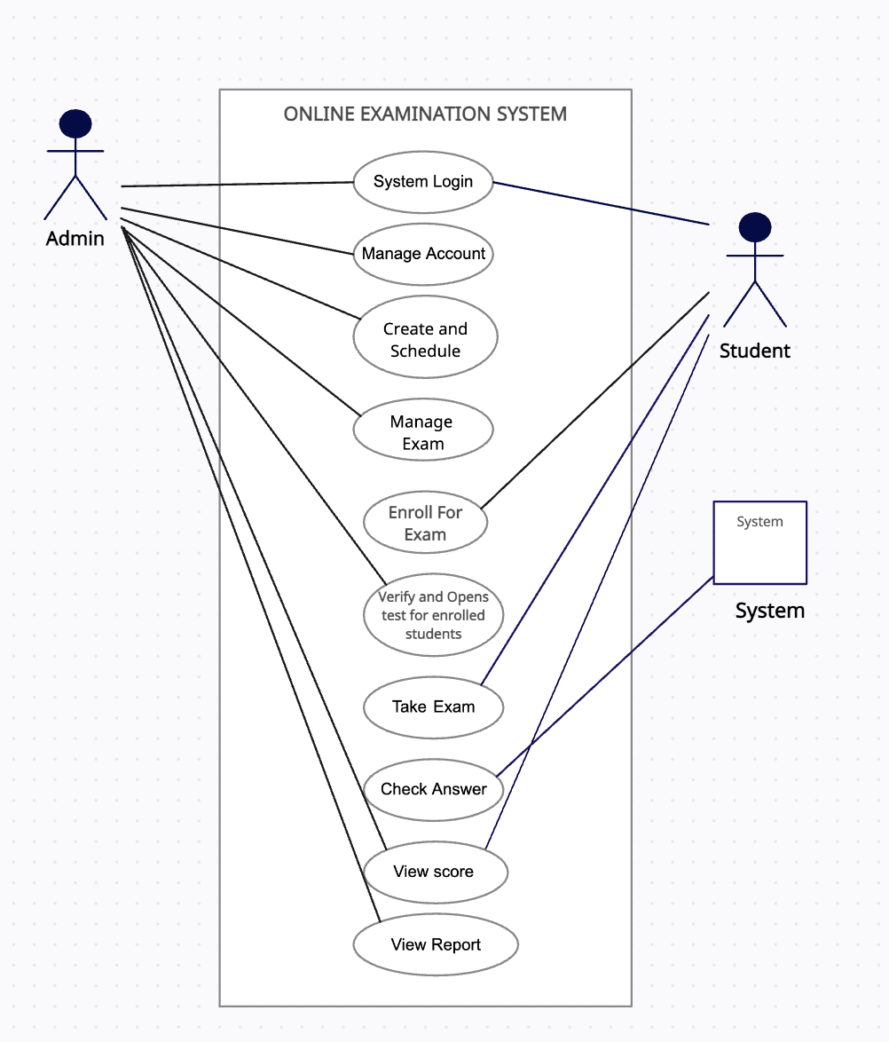

***3.2 Software And Hardware Requirements***

**Programming Language:** Kotlin and JAVA

**Database:** Firebase

**Operating System:** Android, Windows

**IDE:** Android Studio

**Processor (CPU):** A modern multi-core processor (e.g., Intel Core i5 or AMD Ryzen 5) is

sufficient.

**Memory (RAM):** 8 GB to 16 GB of RAM is usually sufficient.

**Storage:** Enough storage to store the application related files generated during the process.

1. ***Experimental Investigations***

Our online exam app is designed to be used in two modules – Administrator and Student. Both modules perform various sets of functionalities.

**[1] Admin**

* View registered students
* Add questions and respective options
* Modify test questions and answers
* Activate or deactivate students
* Send notifications to students
* View results and percentage of marks scored by students

**[2] Student**

* Create an account
* Login
* Register for test
* Take test
* View profile
* Submit test
* View results

**User Roles:**

* **Student:** Take exams, View schedules, Submit answers, View results.
* **Administrator:** Create exams, Manage questions, Schedule exams, Approve and Verify students, View student results.

**User Authentication:**

* Secure login mechanism for both students and administrators.
* Password encryption and secure storage.

**Exam Creation and Management:**

* Admins can create and manage exams.
* Add various questions with options and set time limits.

**Question Management:**

* Admin can Add, edit, and delete questions.

**Exam Delivery and Taking:**

* Students can access exams based on the scheduled time.
* Intuitive user interface for easy navigation during exams.

**Notifications and Reminders:**

* Real-time notifications for upcoming exams, schedule changes.
* Reminder alerts for students to prepare for exams.

**Database and Data Management:**

* Efficient database management to store user profiles, exams, questions, and results.
* Data backup and recovery mechanisms to ensure data integrity.

**Usability and Accessibility:**

* Common user-friendly interface for both students and administrators.
* Students can attend exams from their places at their comfort.

**Scalability and Performance:**

* Ability to handle a large number of concurrent users.
* Optimized performance to ensure smooth user experience.

**Platform and Technology:**

* Android platform using Kotlin programming language.
* Utilization of modern Android development frameworks and libraries.

These design considerations and requirements outline the essential features and functionalities required for an Android-based online exam app. The system should prioritize security, usability, performance, and scalability to provide a seamless and secure examination experience for both students and administrators.

1. ***Result***

***Admin App:***

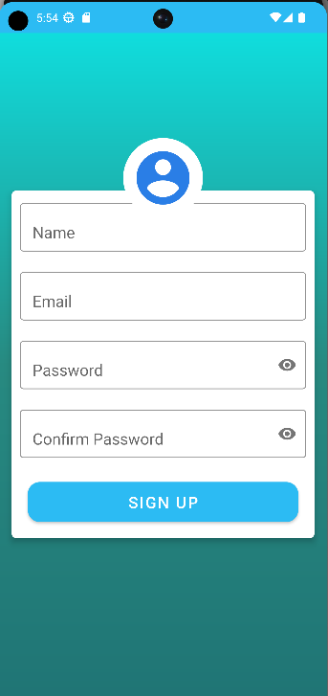 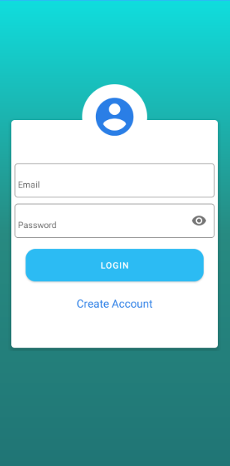

***Admin Sign Up Admin Log In***

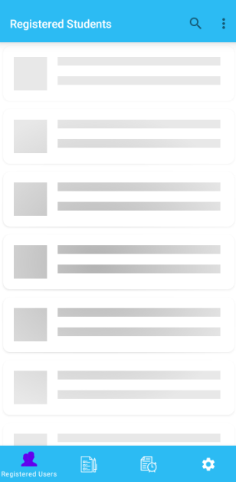 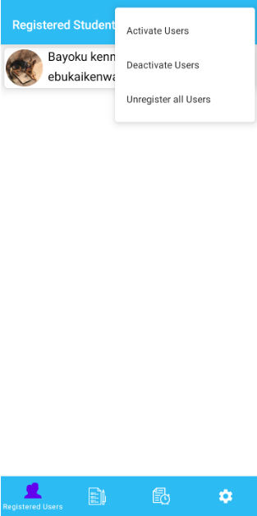

***Registered Students Screen- Registered Students Screen-***

***Before Approval After Approval***

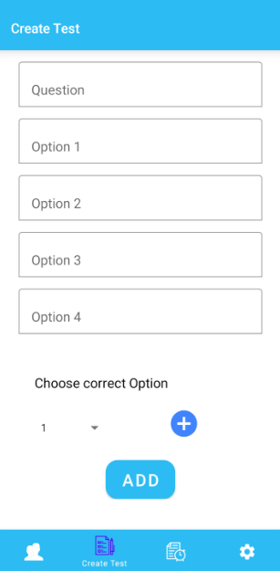 

***Create Test Screen Saved Questions -***

***After Adding the Questions***

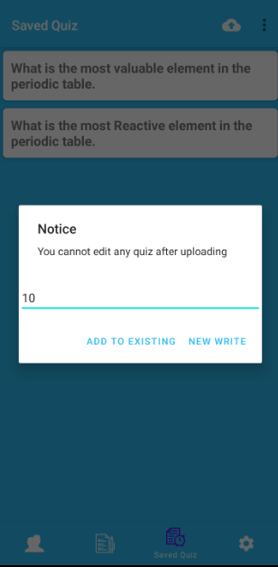 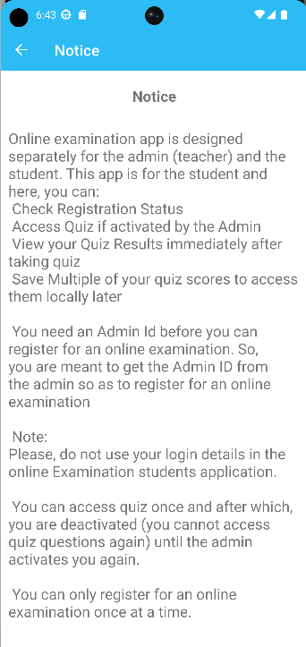 ***Generation of Test Notification Message***

 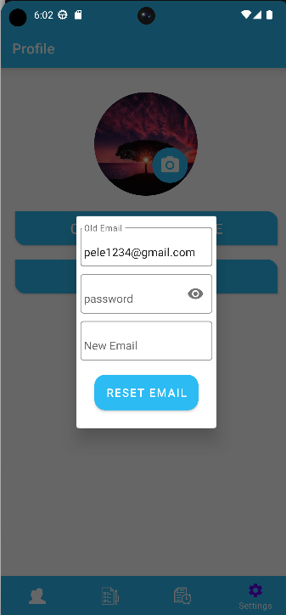

***Profile Screen Update Admin Details***

***Student app:***

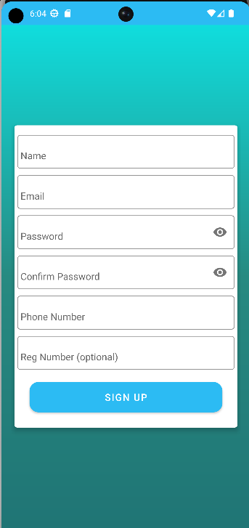 

***Student Sign Up Student Log In***

 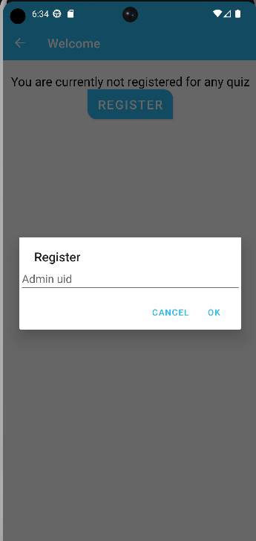

***Home Screen Test Registration***

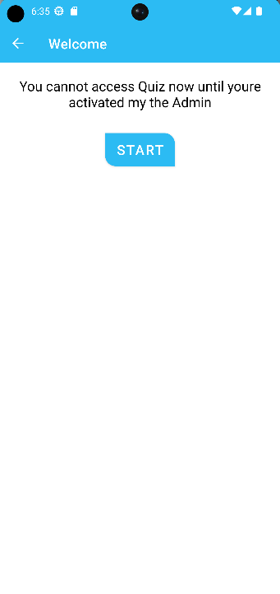 

***Waiting for Approval Test Window***

*** ***

***Test Result window Navigation Bar***

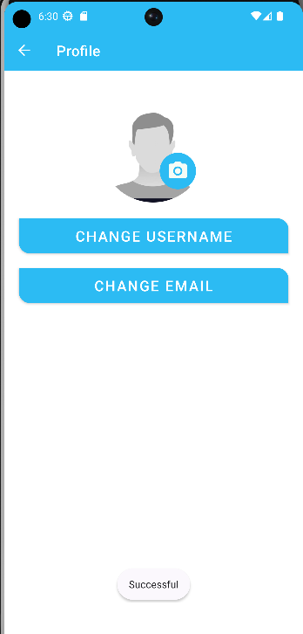 

***Student Profile Saved Results Window***

1. ***Advantages and Disadvantages***

**Advantages of Online Exam Portal:**

* **Accessibility and Convenience:** Students can take exams from anywhere and at any time, providing flexibility in scheduling.
* **Time Efficiency:** Automated grading saves time for educators, and instant result publication benefits students.
* **Enhanced Security:** Measures like remote proctoring and plagiarism detection maintain exam integrity.
* **Customization:** Educators can create personalized exams with various question types.
* **Data-Driven Insights:** Online portals provide valuable data for analytics and informed decision-making.

**Disadvantages of Online Exam Portal:**

* **Technical Issues:** Dependence on internet connectivity and technology may lead to disruptions.
* **Cheating Risks:** Despite security measures, some individuals may find ways to cheat.
* **Lack of Personal Interaction:** Limited direct communication between students and educators during exams.
* **Digital Divide:** Unequal access to technology can create disadvantages for some students.
* **Limited Practical Assessment:** Hands-on assessments may be challenging to conduct online.

1. ***Applications***

The "Online Examination Portal" project has various applications and can be implemented in the following scenarios:

**1. Educational Institutions:** The application can be used by schools, colleges, universities, and other educational institutions to conduct online exams for their students. It provides a convenient and efficient way to assess students' knowledge and skills remotely.

**2. Certification and Licensing Bodies:** Organizations responsible for certification exams or professional licensing can utilize the online exam portal to administer tests. This ensures a standardized and secure assessment process while eliminating the need for physical exam centers.

**3. Recruitment and Employment Tests:** Companies and recruitment agencies can leverage the online exam portal for conducting pre-employment assessments, skills tests, and aptitude exams. It streamlines the hiring process and allows candidates to take exams from anywhere, eliminating the need for in-person testing.

**4. Training and e-Learning Platforms:** Online training platforms and e-learning websites can integrate the online exam portal to evaluate learners' progress and provide certifications upon successful completion of the exams. It enhances the learning experience by providing an integrated assessment solution.

**5. Government and Public Sector Exams:** Government organizations responsible for conducting competitive exams, civil service tests, or other public sector assessments can adopt the online exam portal to make the process more accessible and efficient for candidates.

**6. Continuing Education and Professional Development:** The online exam portal can be employed in continuing education programs, professional development courses, and certification programs. It enables remote evaluation of participants' knowledge and facilitates lifelong learning opportunities.

**7. Remote Learning and MOOCs:** Massive Open Online Courses (MOOCs) and distance learning platforms can utilize the online exam portal to assess learners' understanding of course material and grant certifications or academic credits.

These are just a few examples of the potential applications of the "Online Examination Portal" project. The solution offers a versatile platform for conducting exams remotely, making it suitable for a wide range of educational, professional, and assessment scenarios.

1. ***Conclusion***

In conclusion, the implementation of an online exam portal offers a range of features that revolutionize the assessment process in education. The portal's accessibility and convenience allow students to take exams anytime and anywhere, overcoming the limitations of physical location and scheduling conflicts. With automated grading and instant result publication, the system provides timely feedback to students and saves valuable time for educators. The advanced security measures, such as remote proctoring and authentication mechanisms, ensure the integrity and fairness of the exam process. The system has customization options that enable educators to create tailored assessments, while the data-driven insights and reporting features provide valuable information for analyzing student performance and informing instructional strategies.

The online exam portals have successfully solved the problem of traditional exam limitations, revolutionizing the assessment process and providing a user-friendly and comprehensive solution for modern education. Overall, the online exam portal establishes a user-friendly and efficient platform that enhances the assessment experience for students and educators, promoting a fair, inclusive, and technologically advanced evaluation system in education.

1. ***Future Scope***

The future of online exam portals holds immense potential for innovation and growth. With advancements in technology, these portals will become even more sophisticated and user-friendly. Artificial intelligence and machine learning algorithms will enable personalized and adaptive exams, tailoring the experience to each individual's strengths and weaknesses. Remote proctoring technologies will continue to evolve, ensuring the integrity of exams and preventing cheating. Virtual reality simulations will provide realistic and immersive exam environments, particularly in practical subjects. Blockchain technology will enhance the security and authenticity of certifications and verification processes. Gamification elements and collaborative features will make exams more engaging and foster a sense of community among candidates. Mobile accessibility will be a key focus, enabling users to take exams on smartphones and tablets. Real-time feedback and detailed performance analysis will provide valuable insights for candidates and educators, facilitating targeted improvements. With continuous research and development, online exam portals will play an increasingly vital role in modern education and assessment.

Furthermore, the incorporation of AI-driven automated grading systems will expedite the evaluation process for objective-type questions, saving valuable time for instructors and exam administrators. The continuous evolution of remote lab experiences will enable students to conduct experiments and practical activities from the comfort of their homes, fostering hands-on learning in a virtual environment. Moreover, online exam portals will focus on enhancing accessibility features to cater to diverse student populations, ensuring equal opportunities for all individuals, including those with disabilities. By leveraging data analytics and visualization techniques, these portals will provide comprehensive performance insights to students, educators, and institutions, enabling targeted interventions and personalized learning pathways. Overall, the future of online exam portals is bright, with a wide range of advancements that will enhance the exam experience, improve assessment accuracy, and support the evolving needs of educational institutions and learners***.***

***10. Bibliography***

1. <https://utpedia.utp.edu.my/id/eprint/13518/1/12272_dissa%20adoum%20baba.pdf>
2. <https://exam-portal-django.herokuapp.com/>
3. <https://www.researchgate.net/publication/312002147_Developing_an_Online_Examination_APP_System>
4. [https://www.researchgate.net/publication/30157823_MOBILE_DEVICE_SUPPORTED_ONLINE_EXAMINATION_SYSTEM_APPROPRIATE_TO_DISTANCE_LEARNING](https://www.researchgate.net/publication/301578243_MOBILE_DEVICE_SUPPORTED_ONLINE_EXAMINATION_SYSTEM_APPROPRIATE_TO_DISTANCE_LEARNING)
5. <https://www.researchgate.net/publication/261311174_Design_and_Implementation_of_an_E-exam_System_Based_on_the_Android_Platform>
6. <https://www.researchgate.net/publication/323676476_Mobile_based_secured_student_online_exam_system>
7. https://www.vidyalayaschoolsoftware.com/blog/2022/06/complete-guide-to-online-examination-management-system/

***Appendix***

***Student app MainActivity Code :***

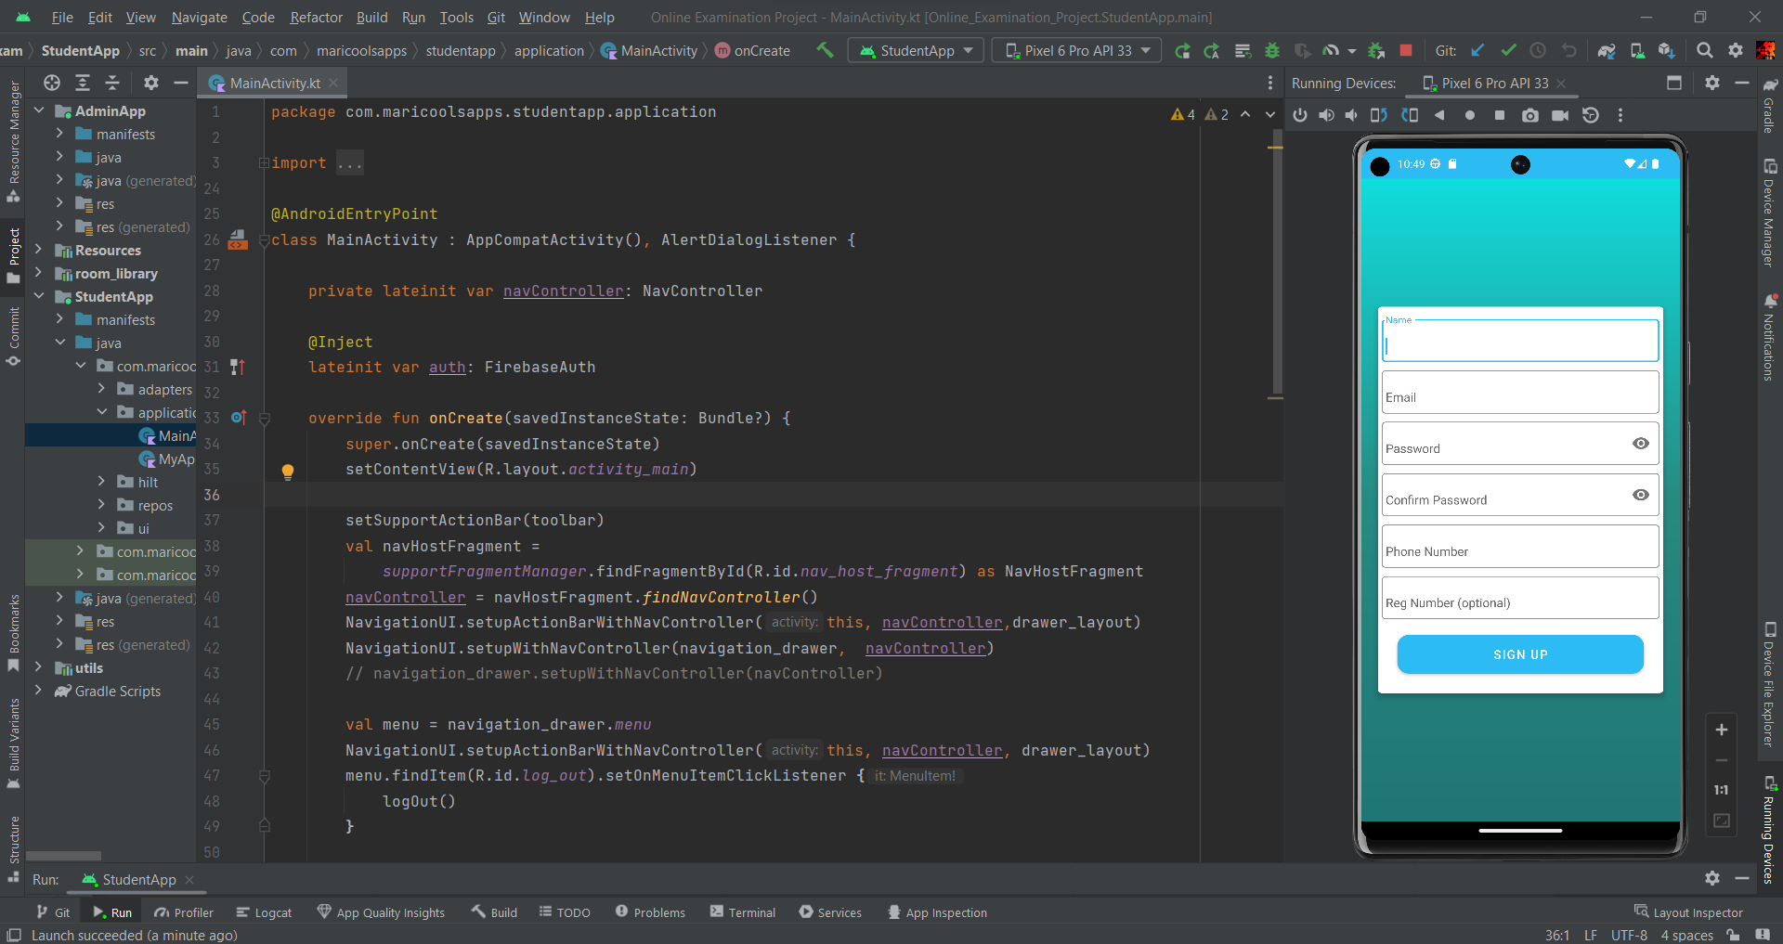

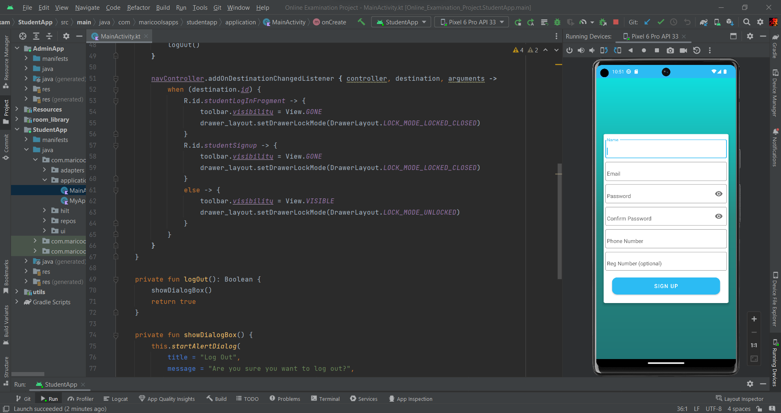

***Admin App MainActivity Code :***

